
Production Assemblers Cresco, IA (USA), Full time

Donaldson is committed to solving the world’s most complex filtration challenges. Together, we make cool things. As an established technology and innovation leader, we are continuously evolving to meet the filtration needs of our changing world. Join a culture of collaboration and innovation that matters and a chance to learn, effect change, and make meaningful contributions at work and in communities. ​

Our Cresco, Iowa plant is hiring for Production Assemblers on all shifts.

Standard work is Monday -Friday with occasional Weekend Overtime (6 hr shifts)
1st Shift 6am-2pm
2nd Shift 2pm-10pm
3rd Shift 10pm-6am

Starting pay: $22.30/hr. Additional $1.50/hr. Shift Differential for 2nd and 3rd shifts.

Additional Benefits:

Medical, Dental, and Prescription, Virtual Care (Dr. on Demand) Online Health Coaching, and 100% coverage of preventative care.
Leaves for Health Appointments, Accident & Sickness Disability benefits, FMLA


2 weeks paid vacation (post 60 days probation/prorated first year)
13 paid holidays, Overtime opportunities at 1.5x/2.0x normal rates
24/7 Employee Assistance Program and Counseling

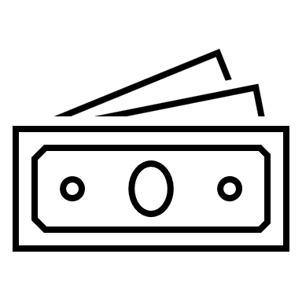
401k, Health Savings Account, Disability, Life, and Critical Illness, Employee Stock Purchase Plan, Educational Leaves, Legal and Financial Resources (EAP)

Ready to join our Donaldson Corporation Family?

Job Responsibilities Include:

- Assembly of multimedia filters utilizing Standard Operating Procedures and Work Instructions
- Operation of various types of machinery to process materials/assemblies throughout the facility.
- Inspect parts using quality inspection tools such as calipers, height gages, etc. per testing instructions and procedures.
- Utilizes hand tools, measuring devices, adhesive applicators, and paper media cutting equipment in a safe and compliant manner
- Report labor, production, scrap and other information into production systems.
- Wear proper safety equipment (PPE)and follow Safety Protocols throughout the plant.
- Keep work area organized at all times, perform preventative maintenance as needed.
- Flexibility to move from line to line or position to position as needed including rotation for ergonomic purposes.
- May be required to assist with training, instruction, or mentorship of employees in training.
- Complies with all DOT, HAZMAT, Donaldson Safety and Environmental policies/laws/rules and company codes of conduct and procedures.

Other Qualifications:
- Perform a variety of tasks safely throughout the day in a fast-paced work environment.
- Interact constructively and effectively with all plant employees while following Donaldson company policies/procedures.
- Ability to work in a team environment toward a common goal.
- Reacts to change productively and demonstrates ability to perform other tasks as assigned.
- Maintains a pattern of regular and predictable attendance and is able to work non-traditional shifts and weekends if required.
- All employees must successful complete a 60-day probationary period.
- All offers of employment are subject to successful completion of the pre-hire applicant process including Drug & Background screenings prior to employment.

Physical Environment:
- Work in an Industrialized environment with equipment including motorized vehicles, rotating equipment, manual and power hand tools and production lines.
- Ability to lift/carry 25lbs frequently and 50lbs occasionally. Ability to stand for long periods.
- Fast paced, team environment requiring hearing protection and PPE

